**CI/CD PIPELINE:**

**What Is CI/CD?:**

Continuous Integration (CI) and Continuous Deployment (CD) form a development practice that automates the build, test, and release of software.

The goal is to detect issues early, reduce manual effort, and deliver features to users faster.

By merging code changes frequently and automating validation, teams maintain a healthy codebase and accelerate feedback loops.

Key Benefits

* Faster feedback on new code changes
* Reduced manual testing and deployment errors
* Consistent, reproducible release processes
* Improved collaboration across development, QA, and operations

**Core Components:**

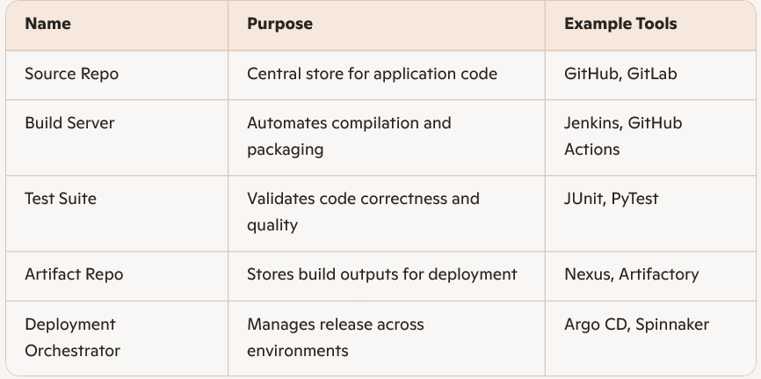

|  |  |  |
| --- | --- | --- |
|  |  |  |
|  |  |  |
|  |  |  |
|  |  |  |
|  |  |  |

**2: Designing and Implementing Pipelines:**

Typical Pipeline Stages

1. Code Commit
2. Build & Compile
3. Automated Tests
4. Static Analysis
5. Artifact Publishing
6. Deployment to Staging
7. Approval Gates
8. Production Rollout

Selecting Your Toolchain

* Align with existing skills and infrastructure
* Ensure tight integration between source control and build engine
* Look for built-in support for containerization when needed
* Evaluate community plugins and ecosystem maturity

**Integrating with Version Control:**

* Trigger CI jobs on pull request or merge to main branch
* Enforce branch protection rules to require passing pipelines
* Leverage feature branches for isolated testing

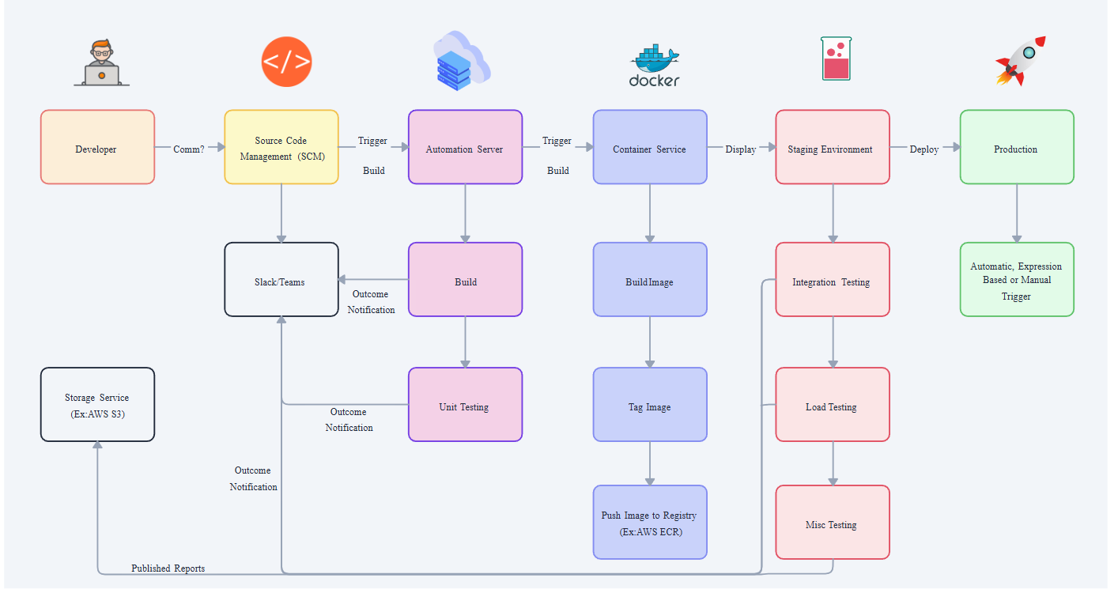

**3: Best Practices & Advanced Topics:**

**Security and Compliance**

* Scan dependencies for vulnerabilities as part of the build
* Store secrets securely using vaults or encrypted variables
* Enforce least-privilege for CI service accounts

**Scaling and Performance**

* Parallelize independent test suites
* Cache build artifacts and dependencies between runs
* Use container-native builds to reduce environment drift

**Monitoring and Feedback**

* Integrate pipeline status badges into documentation and pull requests
* Send notifications on failures to chat channels or ticketing systems
* Capture metrics (build duration, failure rates) for continuous improvement

**Real-World Example: Microservices Rollout**

* Each microservice maintains its own pipeline with shared library for common steps
* Canary deployments to evaluate performance with live traffic
* Automated rollback on health-check failures